Early Spanish Romanization system for Southern Min
Henning Klöter
Research Unit on Taiwanese Culture and Literature
Ruhr-Universität Bochum (Germany)
DRAFT ONLY, DO NOT CITE WITHOUT PERMISSION
The Western encounter with Asia and the Americas after the 15th century triggered a growing interest in non-European languages. The linguistic diversity of the far West and of the far East was first recorded by European missionaries. The early Western encounter with China’s local languages is evidenced in a number of missionary manuscript descriptions of Southern Min, a subgroup of the Sinitic Min variety. The paper provides an introductory description of the earliest extant manuscript grammars and dictionaries. These were compiled by Dominican missionaries working in the Chinese community of Manila during the 17th century. The analysis embraces both historical and linguistic aspects. In its historical components, it will describe the context of Spanish missionary linguistics among the Chinese community of Manila in the 17th century. This historical contextualization will address outstanding questions on authorship and years of compilation of extant manuscripts. On the linguistic side, the manuscripts are analyzed as sources of information on the Southern Min dialects recorded therein. The analysis focuses on the Spanish romanization systems. It addresses grapheme-phoneme relations in these systems and analyses the function of romanized transcriptions vis-à-vis the Chinese character script.
Keywords: Missionary linguistics, romanization systems

0. Introduction
In the late 16th century, Spanish Dominicans started missionary work among Chinese immigrants in the Philippines. The immigrants spoke a Zhangzhou variety of the Southern Min group of dialects. The missionaries’ philological activities were not only restricted to the translation of the Christian doctrine into the native tongue of the immigrants, but also included the compilation of manuscript dictionaries and grammars. Predating the first Chinese accounts by 200 years, these manuscripts are by far the earliest extant descriptions of early Southern Min pronunciation, vocabulary, and syntax. They also provide invaluable information about early popular conventions of writing the Southern Min vernacular with Chinese characters.
Section 1 of this paper will first provide a brief inventory of extant manuscripts, including information about their present locations. By placing the findings into the context of recent studies on the history of missionary linguistics inside and outside China, it will be shown in that missionary dialect descriptions started roughly at the same time as philological investigations of the court language and the Classical language. The historical contextualization thus contradicts the commonly held view that missionary dialect description was a Protestant innovation of the 19th century (section 2). In section 3, I assess the question whether the romanization system used in the early manuscripts provides information on 17th century Southern Min pronunciation.

1. Early missionary accounts of Sinitic languages
The historiography of missionary linguistics on Sinitic languages has thus far focused on missionary accounts of the languages of China’s elite. When Jesuit missionaries initiated permanent work in China during the 16th century, they embarked upon learning the classical written language of the literati and the quasi-official court language known as guanhua ‘Mandarin’. Mastering these languages was crucial for establishing and maintaining contact with imperial officials. In this respect, the pioneering linguistic achievements of the Jesuits Michele Ruggieri (1543–1607) and especially Matteo Ricci (1551–1610) are widely acknowledged (Standaert 2001: 861-868). Academic interest in early Mandarin has been intensified by the publication of a full translation of the first printed Mandarin grammar by Francisco Varo of 1703 (Coblin and Levi 1999).
On the other hand, the first missionary descriptions of the linguistic diversity of the Sinitic sphere have remained terra incognita. Description of Chinese local languages and dialects is usually associated with the efforts of Protestant missionaries during the 19th century. The Catholic tradition of language description, which goes back to the 17th century, has hardly been documented. The only investigation of a number of missionary manuscripts has been published by Van der Loon (1966, 1967). He convincingly explains that the language recorded in the manuscripts is a Zhangzhou variety of the Southern Min group of dialects. The manuscripts were compiled by missionaries of different denominations working among the Chinese community in Manila, i.e., Augustinians, Dominicans, Franciscans, Jesuits, and others. These missionaries took considerable efforts to learn the dialect of the Chinese immigrants. After all, a good command of local dialects was a necessary precondition for successfully preaching the Gospel among the common people.
The Western missionaries obviously had a clear perception of the linguistic diversity of the Sinitic sphere. The Spanish Dominican Juan Cobo, for instance, writes in the early 17th century (Cobo 16??: 1, translated by Van der Loon 1967: 100 ):
The common language of the whole kingdom of China is Mandarin, which is current in the whole kingdom; and also in the province of Chincheo, which has its own language, which is the one that is spoken here. But it should be observed that in this province there are five languages which are somewhat different from each other, as are Portuguese, Valencian, Aragonese, Castilian and others. The most common is that of Chincheo, and the one that is most widely spoken here, for which reason the grammar and dictionary will be in this language, which is better than to mix them all up—just as one should learn the language of Toledo rather than mixing up Portuguese, Spanish and so on.
The European missionaries compiled several grammars and dictionaries of the Zhangzhou dialect. According to inventories (e.g., Gonzalez 1966) more than 20 manuscripts descriptions of Sinitic languages other than Mandarin or Classical Chinese were compiled in the 17th century. As all previous studies have focused on a few representative sources only, a comprehensive inventory of relevant sources has thus far not been published. Van der Loon’s analysis, for instance, does not incorporate the grammar attributed to De Mancano, which was discovered in the 1980s and which is much more detailed and sophisticated than other manuscript grammars of Southern Min. Of the extant documents, I have thus far located and photocopied the following documents:
Chirino, P. Petrus. 1604. Dictionarium Sino Hispanicum [Spanish-Chinese dictionary]. Ms., 83 pages. Biblioteca Angelica, Rome;
Cobo, Juan. Ca. 1600-1650. Arte de la lengua chiochiu [Art of the language of Zhāngzhōu]. Ms., 23 pages. British Library, London;
?De Mancano, Melcior. ?1620. Arte de la lengua Chiõ Chiu [Art of the language of Zhāngzhōu]. Ms., 33 pages. Biblioteca de la Universidad de Barcelona;
De Nieva, Domingo. Ca. 1600-1650. Bocabulario de la lengua sangleya por las letraz de el A.B.C. [Vocabulary of the language of the Sangleys in the alphabet]. Ms., 222 pages. British Library, London.
Following the common practice of the time, the description of the language follows the tradition of Greek and Latin school grammars. Descriptions of features foreign to European languages can also be found, for example, Southern Min tones and measure words. Southern Min expressions in all sources are rendered by romanized transcriptions following a system which is applied fairly constantly in all documents. The dictionaries contain ample information on 17th century Southern Min lexicon and pronunciation.
Figure 1 shows an excerpt of the manuscript grammar attributed to De Mancano. Following the Greco-Latin model of grammar compilation, the grammar contains sections on verb conjugation.
FIGURE 1: Excerpt from ?De Mancano, ?1620
 | si ‘to be’
 | gua sy | yo soy
 | hosim | bueno
 | lu sy | tu eres
 | hosim | bueno
 | y sy | aquel es
 | hosim | bueno
 | guan si | nosotro somos
 | hosim | buenos
 | lun sy | vosotros sois
 | hosim | buenos

Translation:
I am kind
You are kind
S/he is kind
We are kind
You are kind
The manuscript dictionaries display a rather heterogeneous lexicographical makeup. The arrangement of entries in Chirino’s dictionary follows the graphic structure of characters. Romainzed transcriptions indicate the pronunciation and are placed under the characters. Spanish translations are in the upper right corner of each entry, as exemplified in Figure 2.
FIGURE 2: Excerpt from Chirino’s dictionary
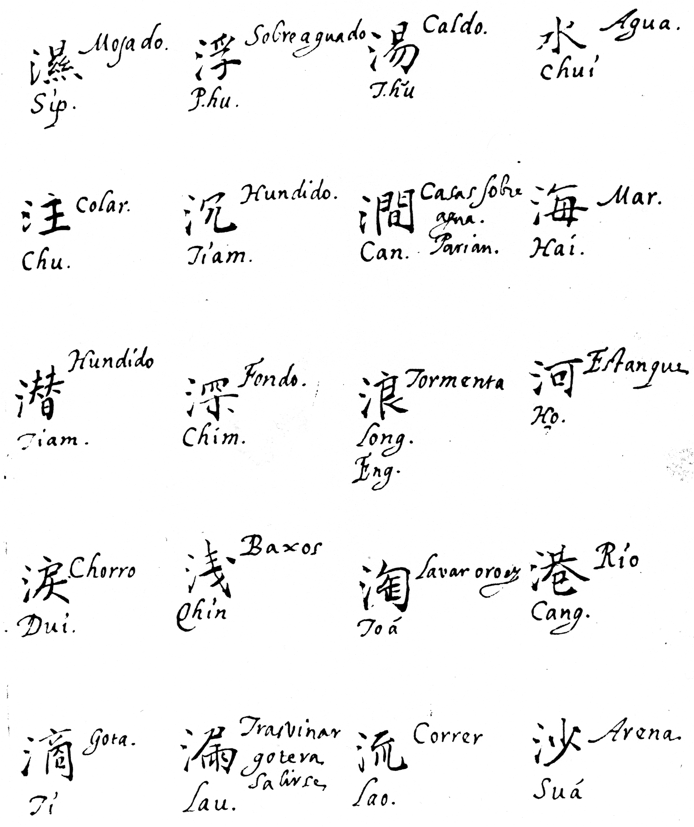
Compared to Chirino’s dictionary, characters are hardly used in De Nieva’s Bocabulario. In this dictionary, entries are arranged in the alphabetical order of the applied romanization system. Each entry is translated; some translations are followed by Spanish explanations and additional example phrases. Characters can be found occasionally, and their location within an entry does not follow a clear system. We may therefore assume that they were added by later users of the Bocabulario.
FIGURE 3: Excerpt from De Nieva’s Bocabulario
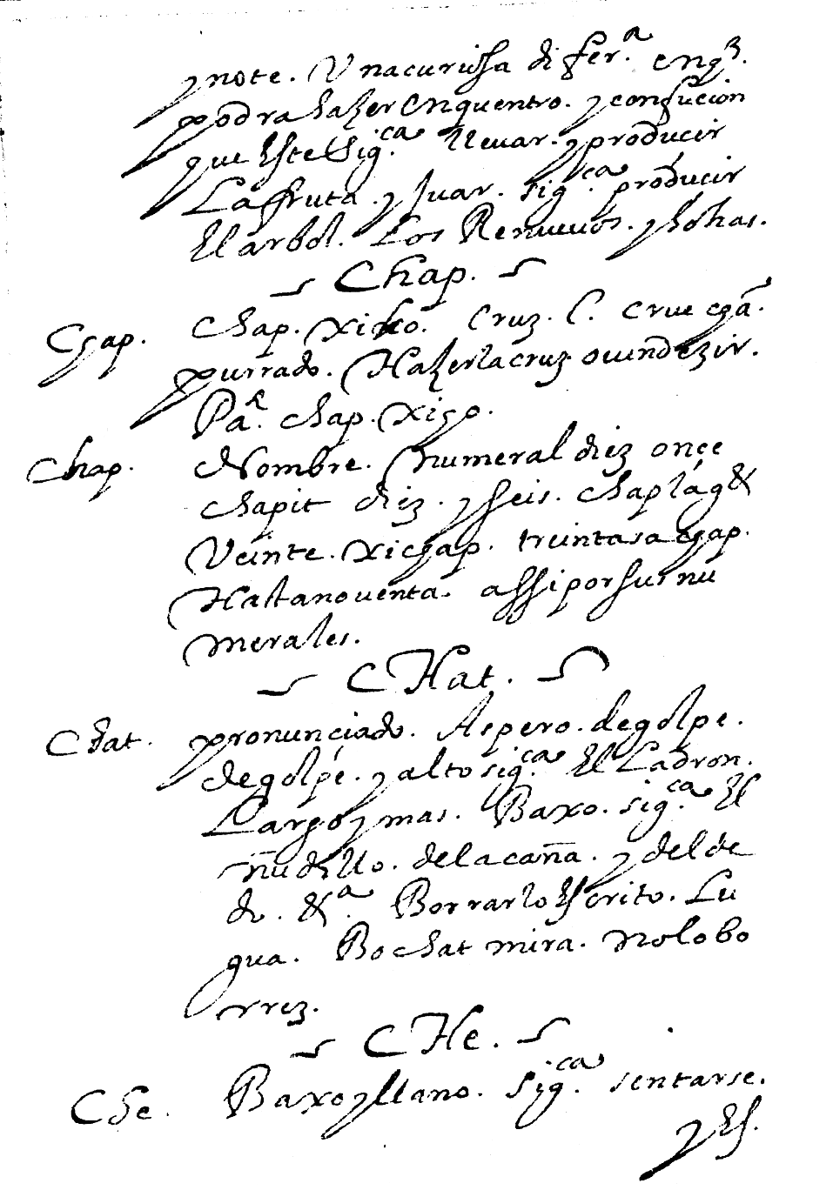

2. The historical context of the manuscripts
The description of Southern Min followed a new trend in the history of language description which was inspired by the grammatical works of the Spaniard Antonio Nebrija. In the late 15th century, Nebrija had written his grammar of the Castillian language, which later served as a model for vernacular language description by Western missionaries in the Far West and the Far East (for details, see Breitenbach 1999). The manuscript grammars attributed to Cobo and De Mancano clearly need to be located in this historical context. As shown in Table 1, the manuscript grammars of the Catholic friars were compiled in the same period as the first accounts on Classical Chinese and Mandarin much earlier than the first dictionaries of Southern Min by Protestant missionaries (e.g., Medhurst 1832, Douglas 1873).
TABLE 1: Missionary descriptions of Sinitic languages
year | work | language
1583/8 | Dizzionario portoghese-cinese (Ricci, Ruggieri) | Mandarin
1604 | Dictionarium Sino Hispanicum [Spanish-Chinese dictionary] (Chirino) | Southern Min
1605 | Xizi qiji [Miracle of Western Letters] (Ricci) | Classical Chinese
?1620 | Arte de la lengua Chiõ Chiu [Art of the language of Zhāngzhōu] (?De Mancano) | Southern Min
Ca. 1600-1650 | Arte de la lengua chiochiu [Art of the language of Zhāngzhōu] (Cobo) | Southern Min
Ca. 1600-1650 | Bocabulario de la lengua sangleya por las letraz de el A.B.C. [Vocabulary of the language of the Sangleys in the alphabet] (De Nieva) | Southern Min
1626 | Xiru ermu zi [An Aid to the Ear and the Eye of Western scholars] (Trigault) | Mandarin
1682/  1703 | Arte de la lengua mandarina [Art of the Mandarin language] (Varo) | Mandarin
1832 | A dictionary of the Hok-këèn dialect of the Chinese language (Medhurst) | Southern Min
1873 | Chinese-English dictionary of the vernacular or spoken language of Amoy (Douglas) | Southern Min

3. The analysis of the sources
Do the sources provide linguistic information on 17th century Southern Min? In general, early missionary descriptions have for a long time been disregarded by 20th century linguistics. It seemed that the predominance of the Greco-Latin grammar model blurred the linguistic makeup of the described languages. For instance, in a cynical comment on early missionary linguistics in the Americas, Angulo writes (1925: 98)
Anyone who has seen some of the grammars published by the early friars knows that they are pretty nearly worthless from every point of view [...] I derived not a little amusement from the fantastic grammars done on a Greco-Latin model by the good priests. I will admit that a good many Zapotecan sounds are rather puzzling to the Spanish ear and present quite a problem in phonetic transcription. But it had never occurred to me that the easiest way out of the difficulty was to write something entirely different.
In the past decade, however, missionary accounts of vernacular languages have received growing scholarly interest. Breitenbach (1999: xxxv), for example, emphasises that:
it was not necessarily the European mindset per se that was manifested in China, but rather the practical use of this concept of grammar. The practical comprehension [the missionaries] had of an ars grammaticae enabled the learner to achieve effectiveness in his speech, to teach the correct word order and sentence structure, to choose the appropriate words, and to pronounce clearly.
The question then arises whether the documents listed in the first section of this paper provide reliable linguistic information about 17th century Southern Min. As regards early Southern Min pronunciation, answers can be found through an investigation of the Spanish romanization system. As I could not find a way to represent the diacritic marks used by the Spanish missionaries with my text processor, I only introduce the linguistic categories on which the use of different diacritics is based. For details, see Van der Loon (1967: 109f.).
Category 1 | “simple mode”;
Category 2 | words pronounced “with the mouth more open than normally”, indicated by two dots on the tone diacritics. As Van der Loon points out, the phonological distinction does not exist in modern Southern Min dialects;
Category 3 | words pronounced “with an effort of the chest”, corresponding to the entering tones (ibid.);
Category 4 | words pronounced “gutturally”, i.e., with an aspirated initial;
Category 5 | words pronounced “gutturally” and “with an effort of the chest”, i.e., with an aspirated initial and an implosive final consonant;
Category 6 | words with an aspirated initial;
Category 7 | words with a nasalized vowel;
Category 8 | words pronounced “nasally but close”, i.e., with syllabic velar nasal
Category 9 | words with an aspirated initial and a nasalized vowel;
Category 10 | words with an aspirated initial and syllabic velar nasal.
As these categories show, the high number of diacritics can be explained by the fact that diacritical marks not only indicate tones, but also phonetic properties of syllable initials and rhymes. Van der Loon’s investigation demonstrates that a phonetic reanalysis of the Spanish romanization system in modern linguistic terminology is possible. Conclusion about phonological contrasts as well as investigations of 17th century Southern Min lexicon and syntax must be left for future investigations. These need to be based on a comparison of the linguistic data in all available sources.

References
Angulo, Jaime de. 1925. “The linguistic tangle of Oaxaca”. Language 1/3, pp. 96-102.
Breitenbach, Sandra. 1999. “Introduction: The biographical, historical, and grammatical context of Francisco Varo’s Arte de la lengua Madarina (Canton, 1703)”. Coblin W. South, Joseph A. Levi, ed. and transl. 1999, pp. ixx-liii.
Coblin, W. South, Joseph A. Levi, ed. and transl. 1999. Francisco Varo’s grammar of the Mandarin language (1703) and English translation of ‘Arte de la lengua Mandarina’. Amsterdam & Philadelphia: John Benjamins.
Douglas, Carstairs. 1873. Chinese-English dictionary of the vernacular or spoken language of Amoy, with the principal variations of the Chang-chew and Chin-chew dialects. London: Trübner & Co.
Gonzalez, José-Maria. 1966. História de las Misiones Dominicanas de China. Vol. V. Madrid: Juan Bravo.
Medhurst, Walter Henry. 1832. A dictionary of the Hok-këèn dialect of the Chinese language, according to the reading and colloquial idioms: Containing about 12,000 characters, the sounds of tones of which are accurately marked; and various examples of their use, taken generally from approved Chinese authors. Batavia.
Standaert, Nicolas, ed. 2001. Handbook of Christianity in China. Volume One: 635-1800. Leiden: Brill.
Van der Loon, Piet. 1966. “The Manila incunabula and early Hokkien studies” (Part 1). Asia Major 12, pp. 1-43.
_____. 1967. “The Manila incunabula and early Hokkien studies” (Part 2). Asia Major 13, pp. 95-186.

